**How to access the Bell Cluster**

1. If you are accessing the server out of the campus, you need to connect to VPN first. How to install VPN? Please refer to https://libguides.uta.edu/offcampus/vpn
2. Configure Xshell and prepare for SSH servers. You can download personal version Xshell from the link <https://www.netsarang.com/en/xshell/>）or find more than 25 alternatives to Xshell (e.g., PuTTY) here: <https://alternativeto.net/software/xshell/>. The following example was made based on Xshell 4, which can also be a case reference for other Xshell alternatives.

**Please refer to the following snapshots as an example, you need to fill in your own account information.**

1. The following figures showcase how to configure a SSH connection to your server (Host: 192.168.1.31, Port Number: 22 ).

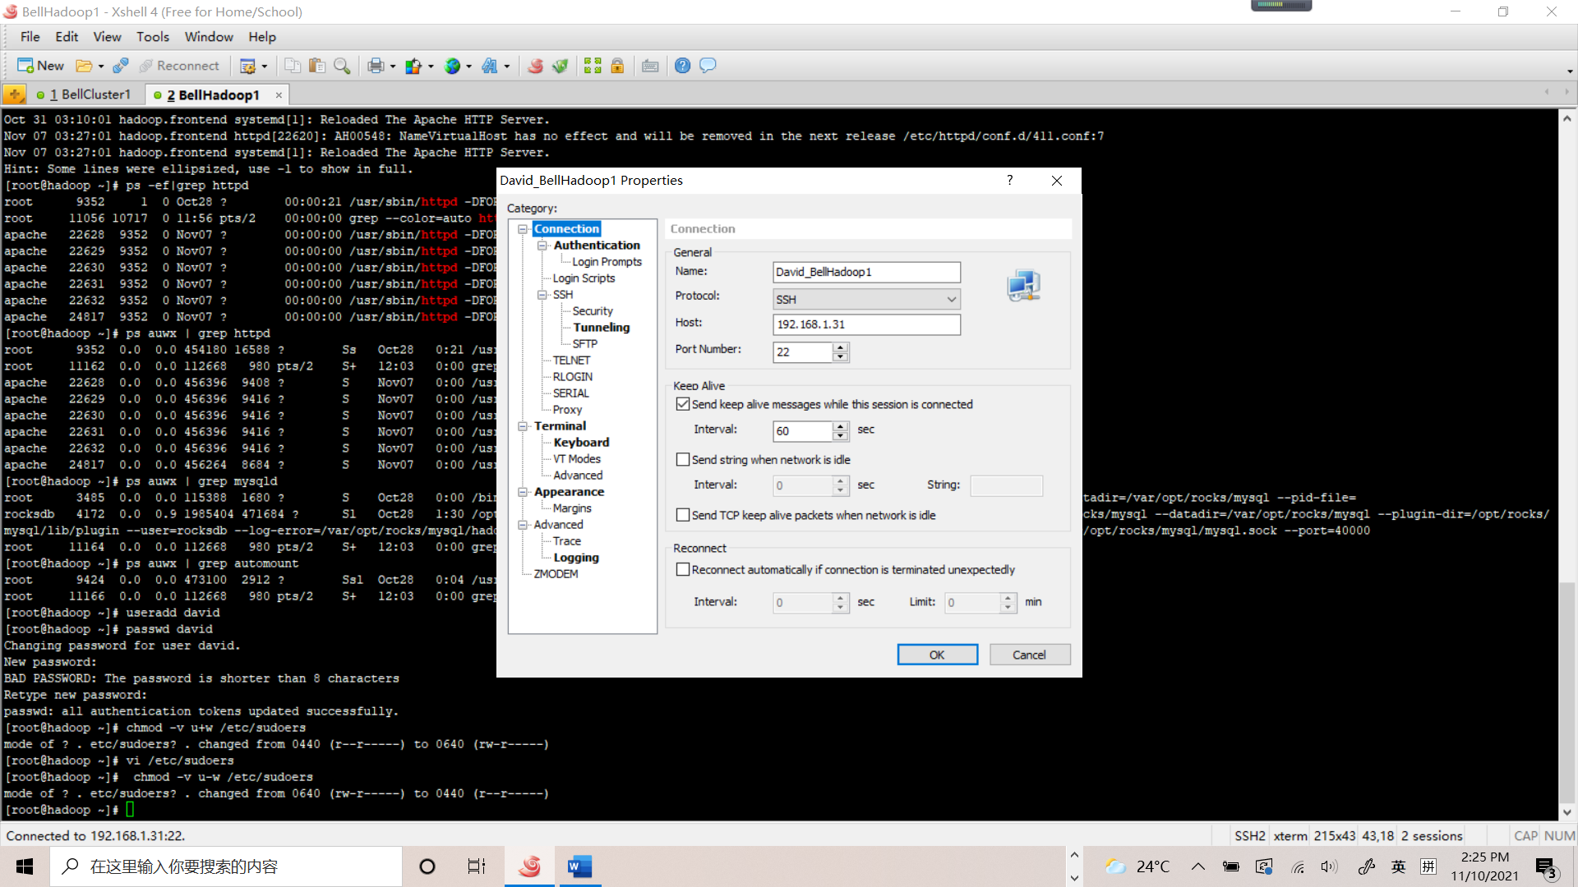

1. Configure Username and Password: 123456; **(You can change the password by yourself**)

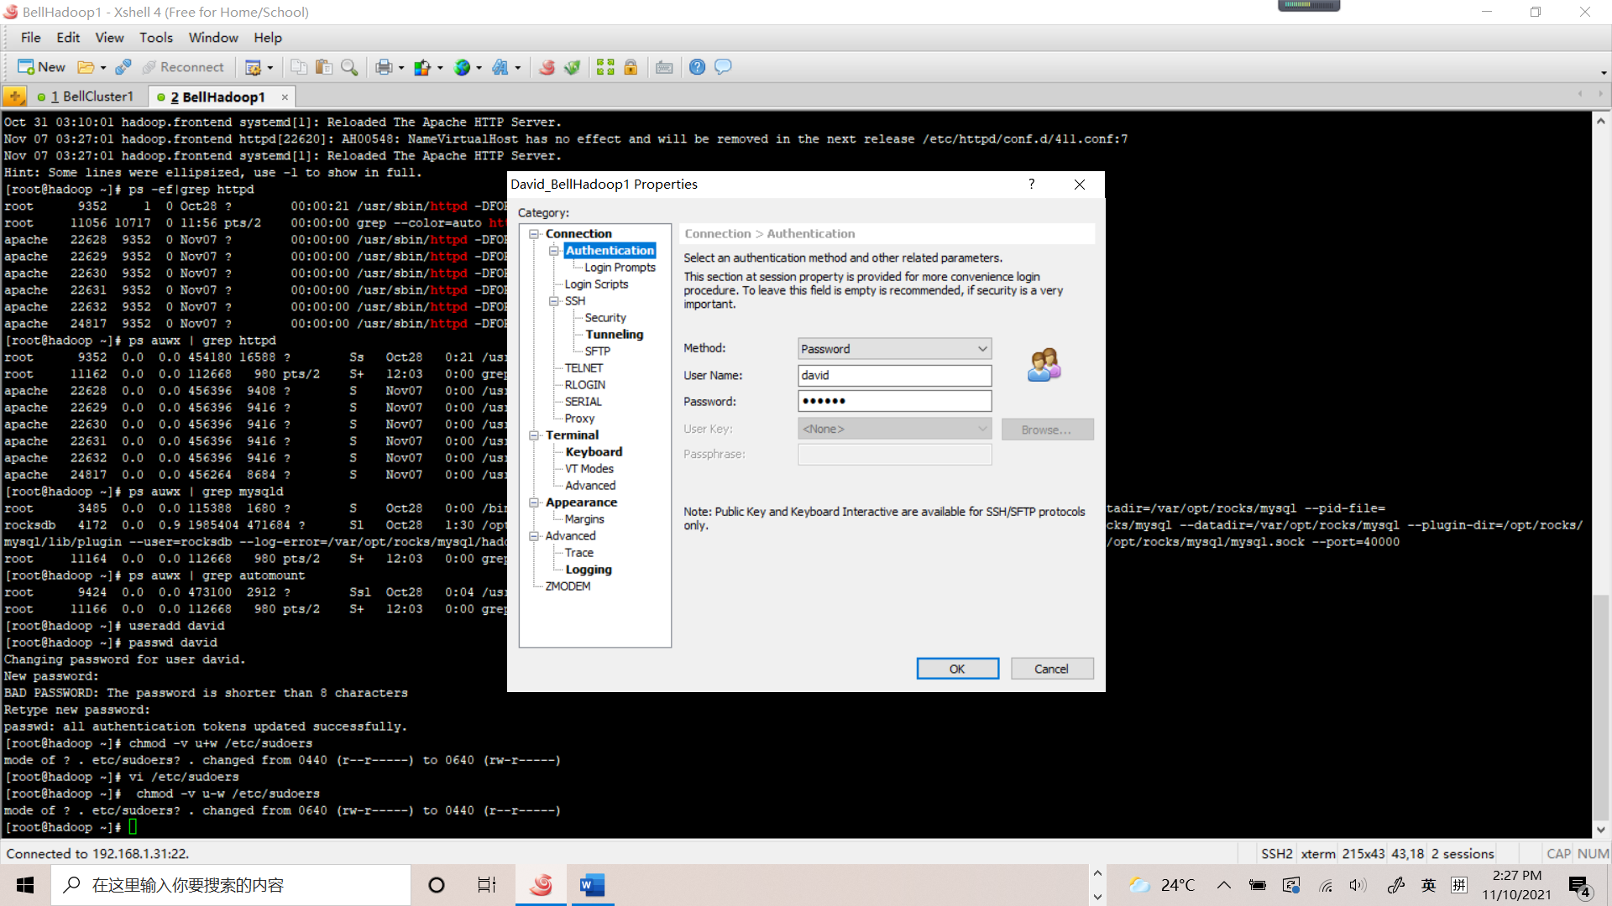

1. Add a proxy with Type: HTTP 1.1, Host: 129.107.35.249, Port: 7771 with Username andPassword: 123456

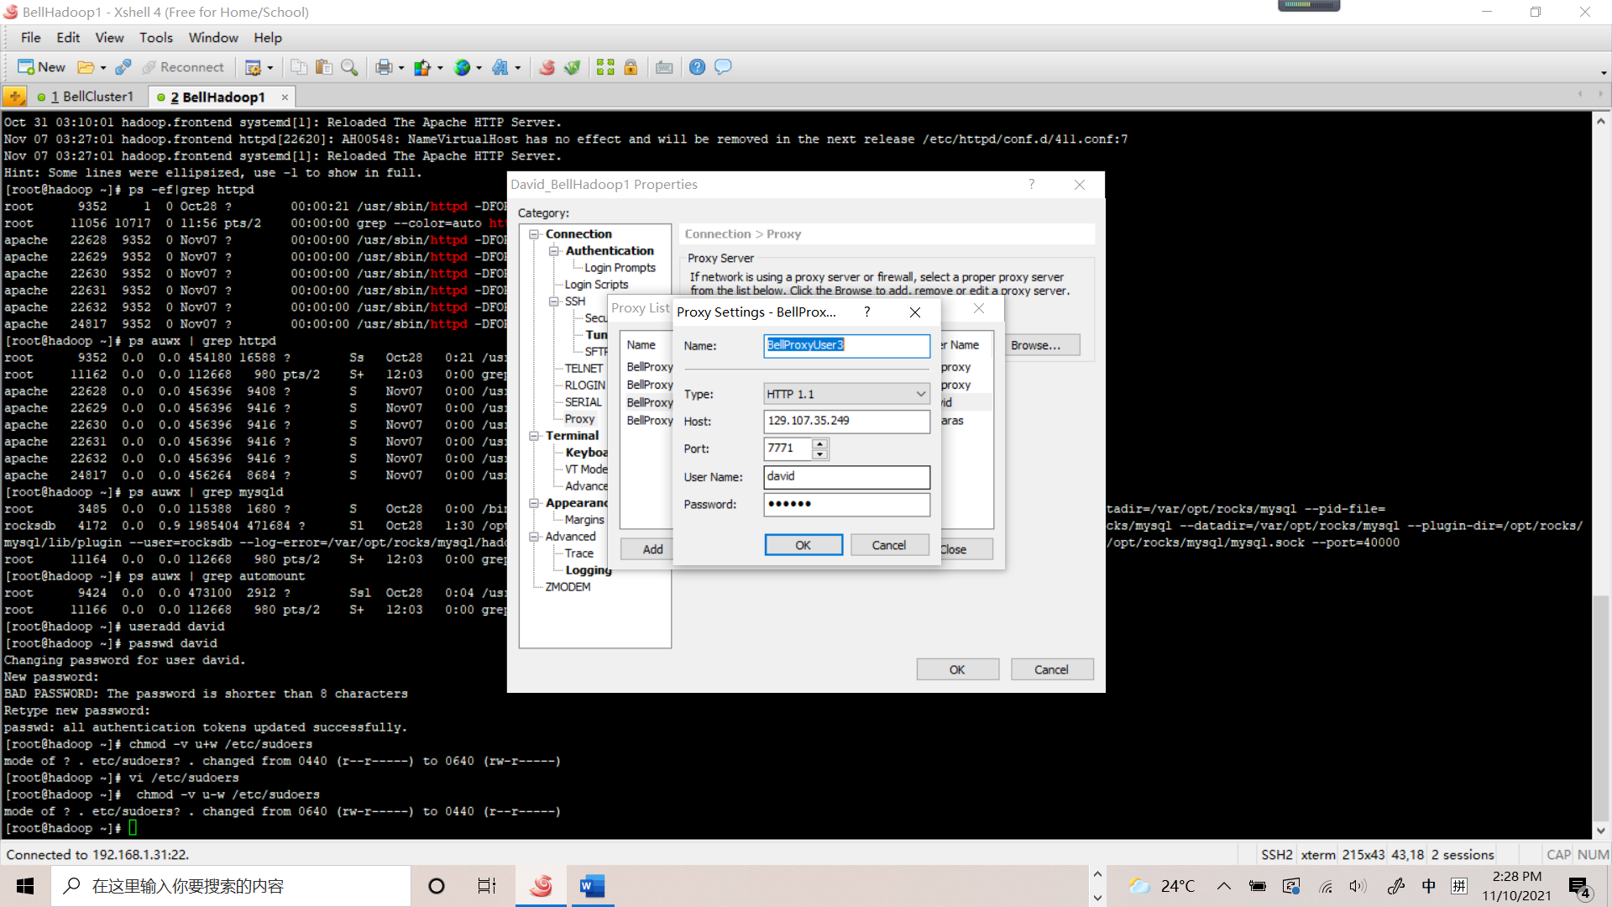

1. And then, at the tab page “Terminal” set “Encoding” as “Unicode (UTF-8)”.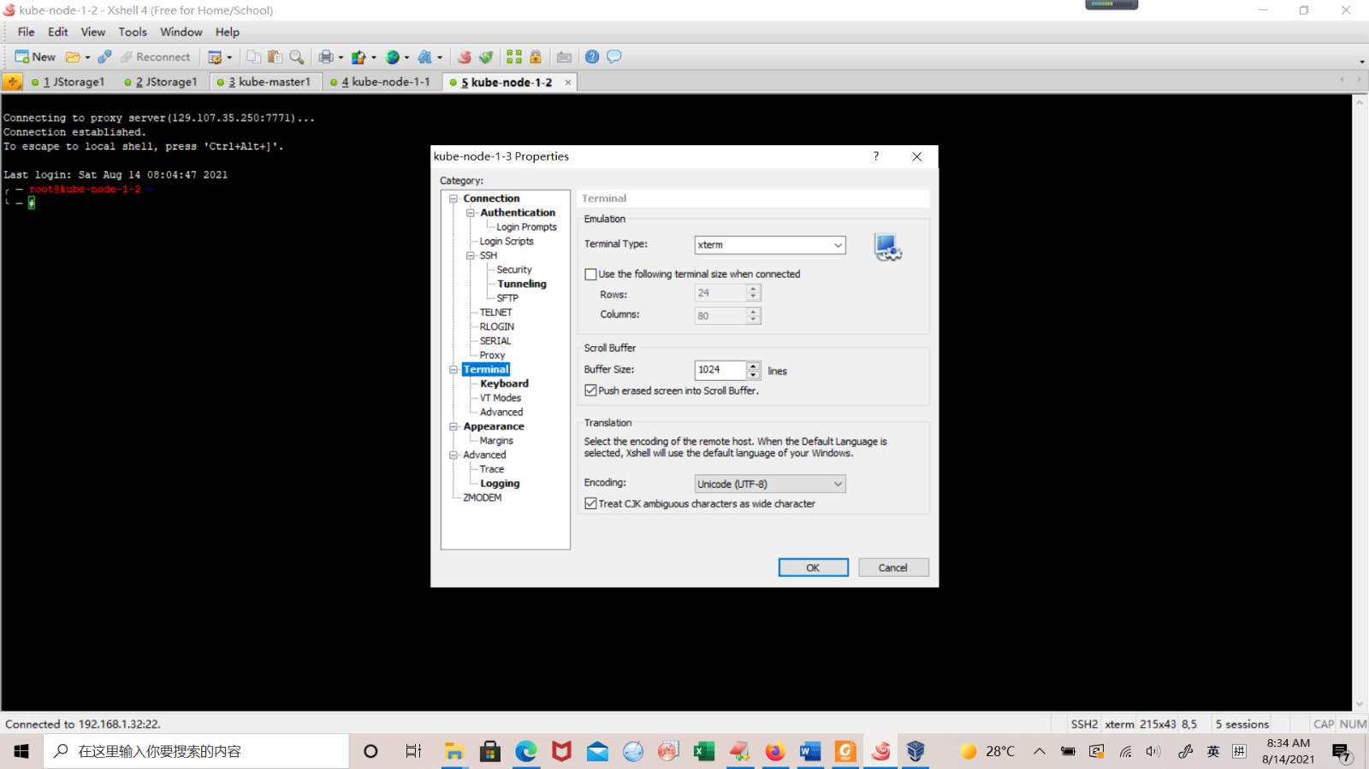
2. You can access the server by Xshell.